Manea Footprints of Kupe

Pre-visit
Activities

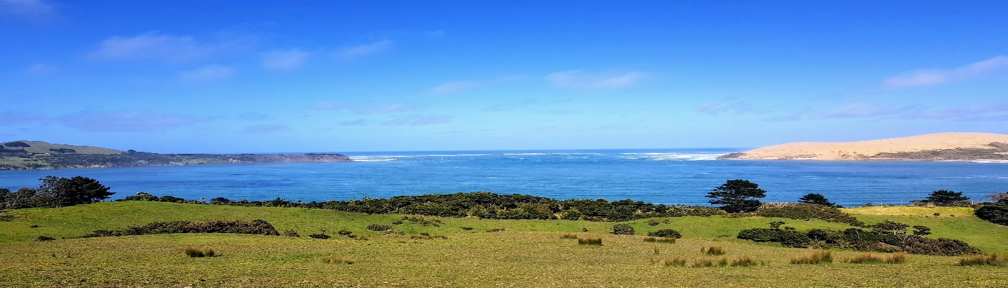

Pre-Thinking Questions

How did our ancestors come to Aotearoa?
Where did they come from?
How did they know where to go?
What do you think the journey would have been like?
What did the waka look like?
How were they built?

Brainstorm your ideas

Where is Hokianga?

Can you find it on a map?

How long will it take to get there from your area?

________________________________________________________

What do you think you will see there?

________________________________________________________________________________________________________________
What are some activities you can do there?

_______________________________________________________________________________________________________________________________________________________________________

What would you like to know more about?

________________________________________________________________________________________________________________________________________________________________________________________________________________________________________________________________________________________________________________________________________________________________________________________________________

Pre-visit Class activities

Date Completed
Brainstorm ideas about the coming of Maori to Aotearoa
Look up on a map where Hokianga is
Discuss ideas about the making of waka and navigation
Form questions about what you would like to know more about

